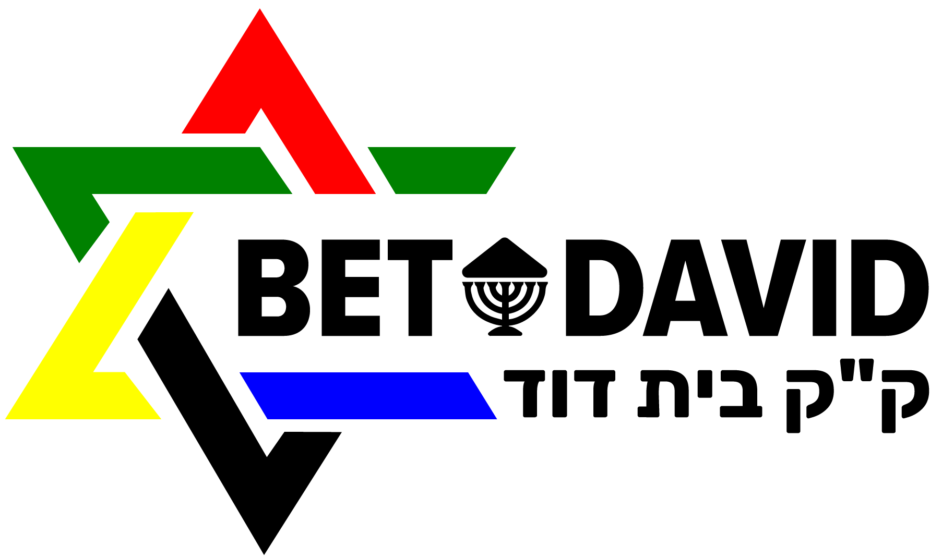
COVID-19
HOME
Search …

https://sacoronavirus.co.za/
Loading...

From our Chairman
A message of support during a crisis is never easy to write. It is more difficult now that we are facing the menacing threat of the unknown. Each of us has a part to play; to do everything we can to keep ourselves and our families from harm and to protect the wellbeing of our communities and fellow South Africans.
It is our hope that Bet David will be able to play an important role managing and alleviating your stress, by assisting you in your worship, prayer and meditation and enabling you always to feel part of our congregation, even during times of isolation. Please join our streamed Erev Shabbat and Shabbat morning services each week, as well as the other planned streamed activities.
The next two weeks would, under ‘normal’ circumstances, have been a busy time of preparation for Pesach, with eager anticipation of very special times spent with close family and friends. This year, for many, the answer to the question, “Why is this night different to all other nights?”, will be filled with sadness and trepidation. We, at Bet David, hope that your Pesach will be a meaningful one. Services will be streamed so that we can worship in our own homes and feel connected to Jews all over the world who are experiencing a most unusual Pesach.
Thank you to Rabbi Schell and Brett Steingo and members of our congregation for ensuring that these services take place and to our very special lay readers who are leading services. Thank you to Ian Mann, Janis Jordan, Doron and the Choir for the first Erev Shabbat service streamed from the sanctuary last week.
Rabbi Schell, the ManCom, Ashley and I, wish you well and hope that you and your families will be safe. In these dark times, we hope to provide some light, in the spirit of the old Jewish Proverb, “A little light pushes away a lot of darkness”. Please do not hesitate to contact us if we can be of assistance to you in any way.
Desmond Sweke, Bet David: Chairman

Please check out the following links for further information: www.betdavid.org.za/online
https://www.sajbd.org/
Talking to your children about coronavirus (UNICEF) https://news.un.org/en/story/2020/03/1059622.
Dear congregants,
In response to the growing number of Covid 19 positive cases in South Africa, the guidelines published by the government, and in the interest of staff members who use public transport, it has been decided to close the synagogue office immediately and reopen on Wednesday, 25 March 2020. There will be also no regular Shabbat service this Friday and Saturday in Shul.
However: We will run services and study sessions online, using tools the internet offers us to remain connected. Links and additional sources will be shared and regularly updated on our website www.betdavid.org.za/online .
We will be also available for you by email and phone. If you want to get hold of us, please send an email to Glynnis (admin1@betdavid.org.za) Diane MC for the cheder (admin2@betdavid.org.za), Diane E (accounts@betdavid.org.za), or Rabbi Schell (rabbi.schell@betdavid.org.za). Rabbi Schell will also answer the phone if you call 011/783-7117 or 076/4486672. Please feel free to use Whatsapp, too: 0764486672.
Please see a short video message by Rabbi Schell here: https://youtu.be/Ntn-U8j4X04
B’vracha
Rabbi Adrian M Schell

12 Mar 2020 NEWS
Dear Congregants,
There is consensus around one fact regarding COVID-19: we are in an evolving situation. Some experts now encourage social distancing – avoiding large group gatherings and situations where there is risk of spreading the virus.
Jewish tradition teaches Kol Yisrael arevim zeh bazeh , that the community of Israel is responsible for one another. By extension, as citizens of the larger world, we are responsible for our neighbours and fellow citizens as well.
At Bet David we will do our part to avoid the spread of this virus, which means modifying some of our routines, and remaining ready to make further modifications. We are all responsible for one another.
Consistent with this teaching, below is information regarding changes to our routines effective immediately and continuing through
Saturday, March 28. We are grateful for our culture of profound connections and are saddened that we cannot nurture those connections in person as we begin to limit physical presence and interactions and implement temporary interruptions to our interactions.
At this point we are continuing with our Shabbat evening and morning services, ITJ, cheder, appointments with the rabbi, and life cycle events. However, we have suspended the brochas after the Shabbat morning service for now.
For Shabbat services, please arrive just before the service starts to limit assembling as a large group. Our new practice is to replace handshakes and hugs with elbow bumps and warm smiles.
Regarding events beyond March 28, information will be provided as the situation continues to evolve. We support you in your decisions regarding how you choose to engage with our community at this time.
Most importantly, if you demonstrate any symptoms, if you are at risk of carrying the virus, or if you or anyone with whom you have been in close contact has a suspected case of COVID-19, please do not visit Bet David.
We look forward to resuming our many in-person activities as quickly as possible.
L’Shalom ,
Rabbi Adrian M Schell
BET DAVID LIVE STREAM

NEWS
The Mitzvah of Being an Ally
Covid 19 Update – Services at Bet David
Pride Shabbat + Shabbat Chukat @ Bet David
A glimpse of the messianic time
Shabbat Korach @ Bet David

CONTACT
BET DAVID
PO BOX 78189 Sandton 2146 Tel: +27 11 7837117 admin1@betdavid.org.za
anti-Semitis
m

Aparthei
d

i
Bechukota

Behaalotech
a

Beha
r

Bemidba
r

h
Chanuka

Corona Viru
s

Emo
r

High Holy Day
s

Israe
l

h
Kehilla

b
Kid's Clu

h
Korac

Kote
l

Lech Lech
a
ManCo
m

h
Mishkan ha Nefes

y
Mitzvah Da

Nas
o

r
Netze

s
New Campu

New Shu
l

Noac
h

r
Ome

Pesac
h

Praye
r

Progressive Judais
m

m
Puri

Re'e
h

Rosh HaShana
h

SAUP
J
t
Shabbat Projec

r
Shabbat Zacho

t
Shavuo

h
Shavuot

Shoa
h

South Africa 2
5

Sukko
t

Talk&Te
a

Torah sparks by Rabbi Schel
l

Vayeitze
i

Western Wal
l

Yom Kippu
r

Zionis
m
Enter your email address to subscribe to this blog and receive notifications of new posts by email.
Email Address
Subscribe
Copyright © 2020 Bet David. All Rights Reserved.
TAGS
GET THE LATEST NEWS FROM BET DAVID BY EMAIL
UPCOMING EVENTS
MITZVAH SCHOOL
PO BOX 78189 Sandton 2146 Tel: +27 11 883 7177 mitzvah@telkomsa.com
Bet David is committed to creating a community of respect and dignity for all who walk through our doors. 